IMPLEMENTATION PLAN OF ENTOMOLOGY FOR
M.Sc (Hons) Degree Program

AT Findings | Corrective Action | Implementation Date | Responsible Body | Resources Needed
No computer laboratory in the department is present. | Establishment of new computer laboratory in the department for M.Sc students | 2012-2013 | Chairman/P&D | New computer laboratory for M.Sc students having ten computers and one printer and other related equipments.
Criterion-7  (Institutional Facilities)  Insufficient Classrooms | Provision of well equipped classrooms . | As soon as possible | Chairman/Director Teaching | Rooms for Classrooms.
No power back up (Generator) | Purchase of generator or UPS to provide electricity in the lecture rooms, offices and laboratories. | As soon as possible | Chairman/ Store Officer | Generator or UPS
The departmental Library, which is currently not upto the required standard, needs funds for up-gradation | Project proposal may be submitted to the HEC for up-gradation of departmental library. | 2012-2013 | Chairman | List to be provided by Dept
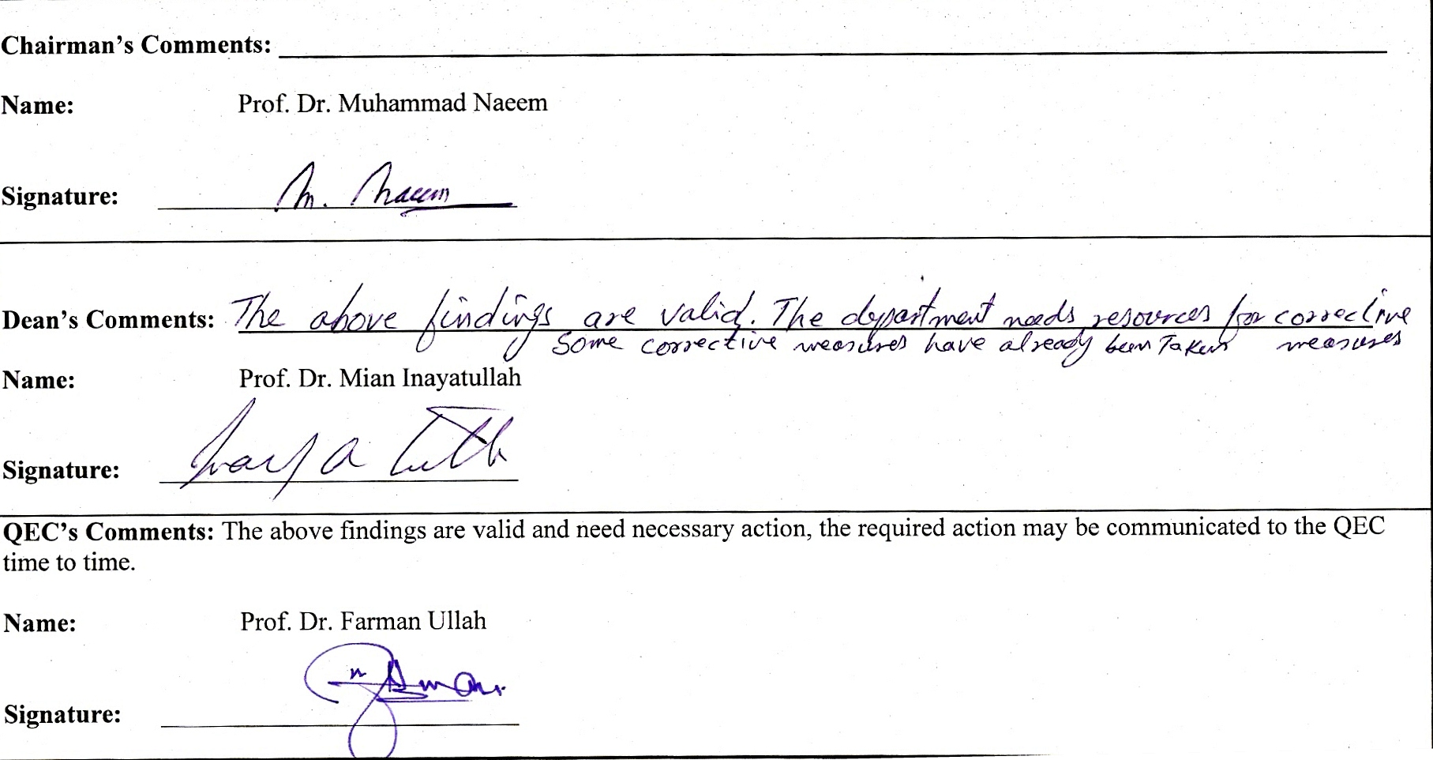

Chairman’s Comments: ____________________________________________________________________________________

Name: Prof. Dr. Muhammad Naeem

Signature: ___________________________

Dean’s Comments: ______________________________________________________________________________________

Name: Prof. Dr. Mian Inayatullah

Signature: ___________________________

QEC’s Comments: The above findings are valid and need necessary action, the required action may be communicated to the QEC time to time.

Name: Prof. Dr. Farman Ullah

Signature: ___________________________

